Nama : Miftahud Dini

Nim : 2301081009

Kelas : TK 2B

Matkul : Keamanan Jaringan

1. Universitas Brawijaya

|  |  |  |
| --- | --- | --- |
| **Target :** 175.45.185.13 |  |  |
| **Os :** Oracle VirtualBox |  |  |
| **DNS Service :** |  |  |
| **Open Port** | **Service** | **Version** |
| 12 | http,… | Apache httpd 2.4.41 ((Ubuntu)) |

1. Universitas Islam Indonesia

|  |  |  |
| --- | --- | --- |
| **Target :** 103.220.113.131 |  |  |
| **Os :** Oracle VirtualBox |  |  |
| **DNS Service :** |  |  |
| **Open Port** | **Service** | **Version** |
| 2 | http,https | Apache httpd 2.0.54 ((Win32) |

1. Universitas Negeri Malang

|  |  |  |
| --- | --- | --- |
| **Target :** 103.208.94.1 |  |  |
| **Os :** Oracle VirtualBox |  |  |
| **DNS Service :** |  |  |
| **Open Port** | **Service** | **Version** |
| 2 | http | OpenResty web app server |

1. Universitas Muhammadiyah Yogyakarta

|  |  |  |
| --- | --- | --- |
| **Target :**103.251.180.32 |  |  |
| **Os :**Windows |  |  |
| **DNS Service :** |  |  |
| **Open Port** | **Service** | **Version** |
| 3 | http,https,http-proxy | Microsoft IIS httpd 10.0 |

1. Universitas Diponegoro

|  |  |  |
| --- | --- | --- |
| **Target :**182.255.1.59 |  |  |
| **Os :**Oracle Virtualbox |  |  |
| **DNS Service :** |  |  |
| **Open Port** | **Service** | **Version** |
| 3 | domain,http,https | ISC BIND 9.11.4-P2 (RedHat Enterprise Linux 7) |

* Universitas Brawijaya

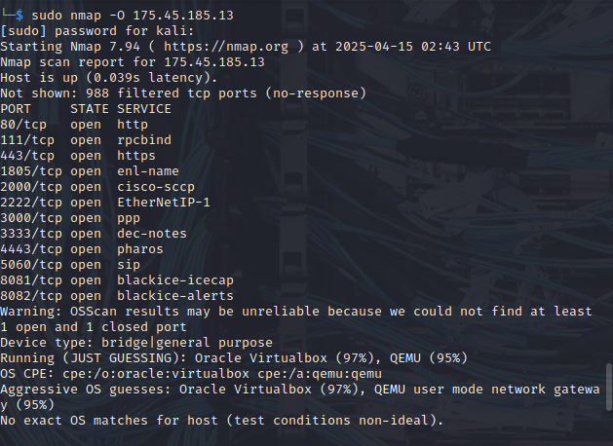

* Universitas Islam Indonesia

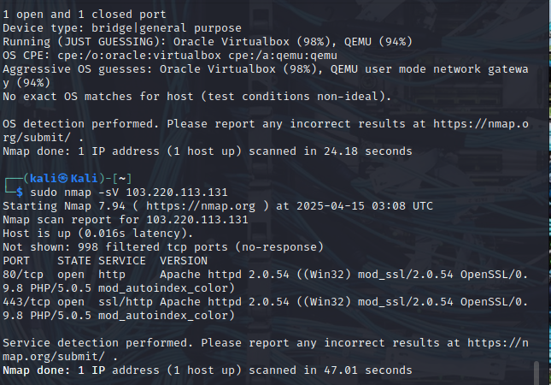

* Universitas Negeri Malang

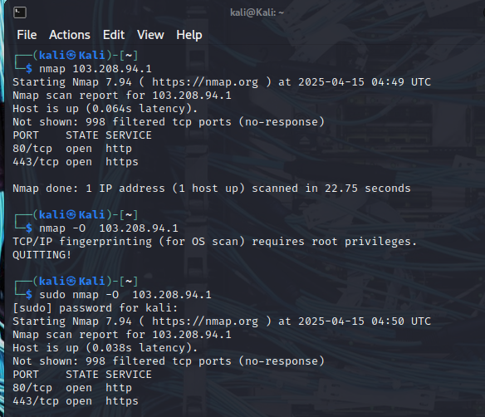

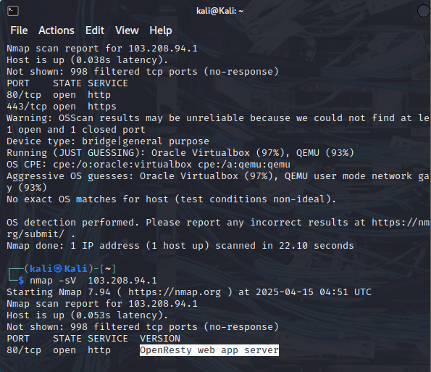

* Universitas Muhammadiyah Yogyakarta

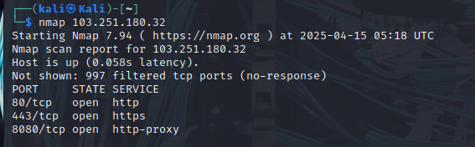

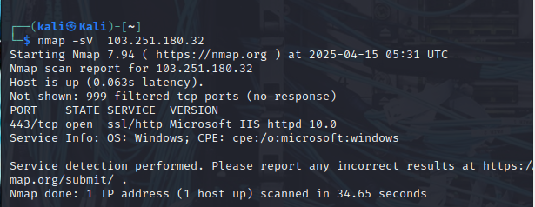

* Universitas Diponegoro

